VILLAGE SQUARE BEFORE

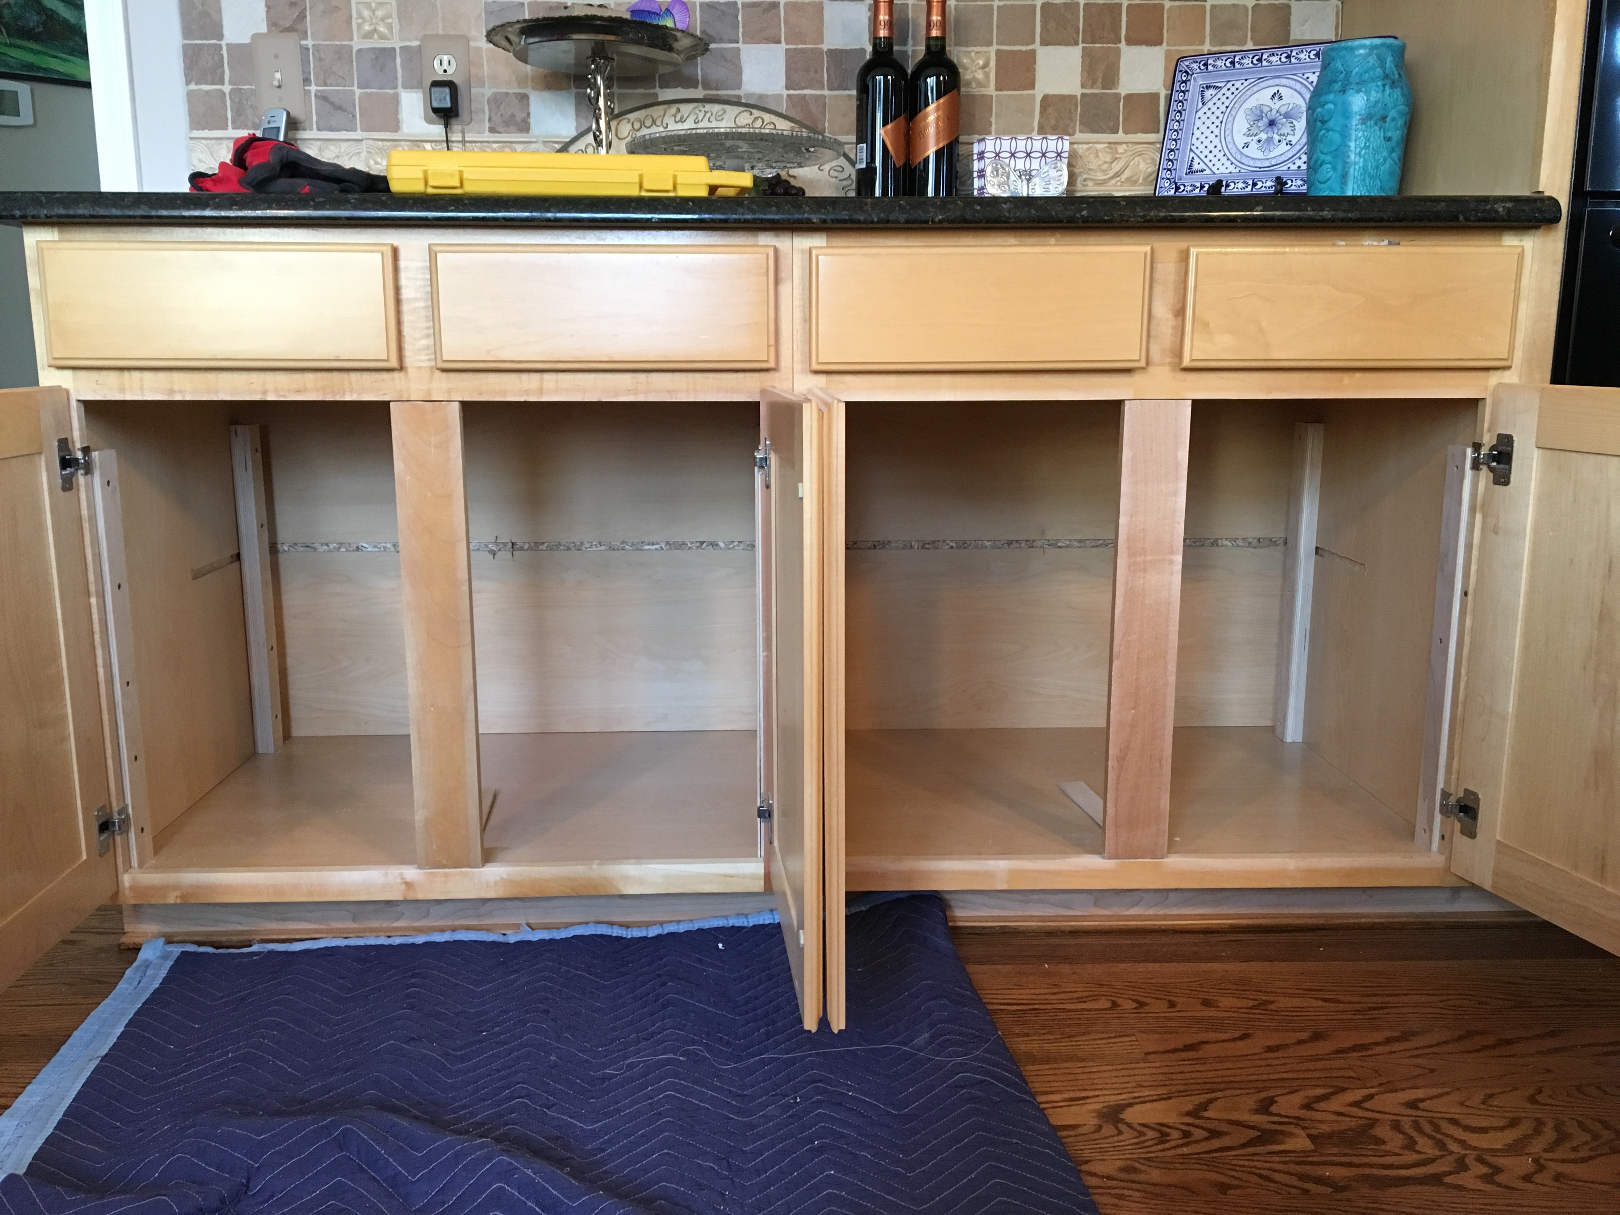

VILLAGE SQUARE AFTER

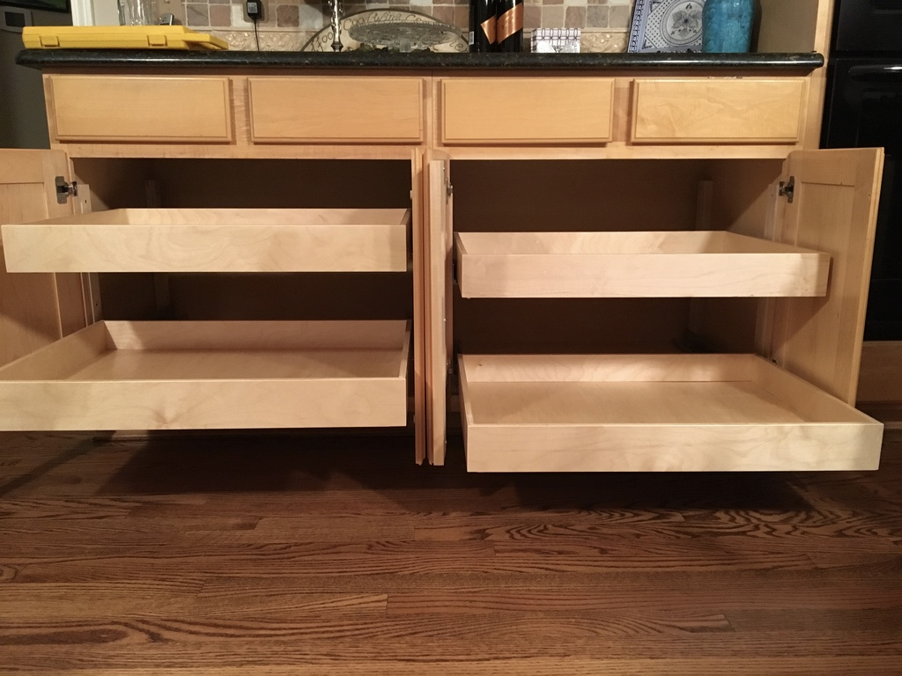

MAPLEHURST BEFORE

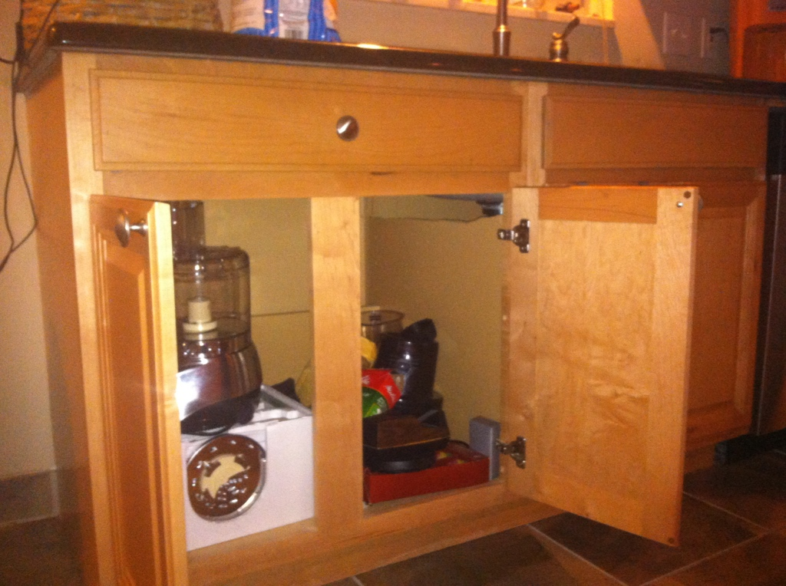

MAPLEHURST AFTER

